- Create virtual environment = python -m venv venv
- Activate vm = venv\Scripts\Activate
- Install reflex = pip install reflex
- Initialize reflex = reflex init
- https://reflex.dev/docs/recipes/
In this reflex docs under recipes we can get a code for layout, content, login form and others.

- Basic index function with style properties
- import reflex as rx

- def index():
- return rx.text('This is a home page', font_size='20px', bg="green", color='red',
- font_weight="bold", _hover={'color':'white', 'bg':'black', 'font_size': '30px'})

- app = rx.App()
- app.add_page(index)
- # app._compile()

7. Run in terminal by write (reflex run)
8. This app._compile() is optional, in previous versions of reflex it used but now when you press the ctrl+S, your code will be compiled and you can see the output.

9. Suppose you have a lot of items that you cannot add to the home page. In that case, you can create a new function for them and then add that function using the add_page() function, where you assign a route for that page.

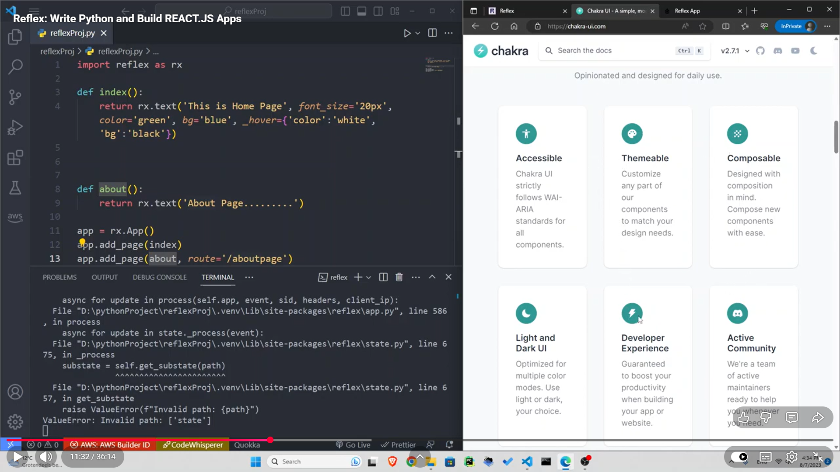

10. As shown in the above image, a new about function was created and then added as a page using the add_page() function.

11. Navbar we will write now
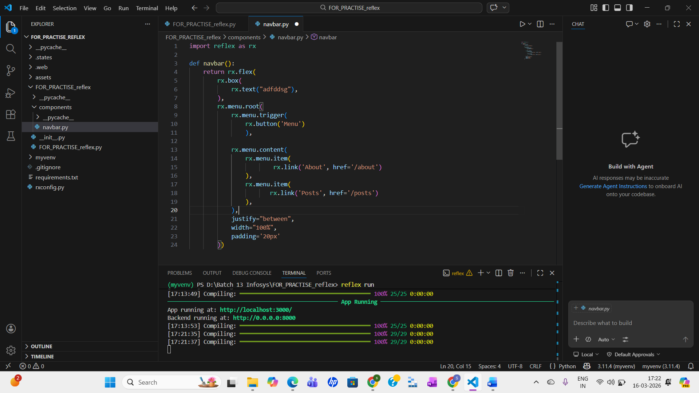

12. In the main file, we will connect this

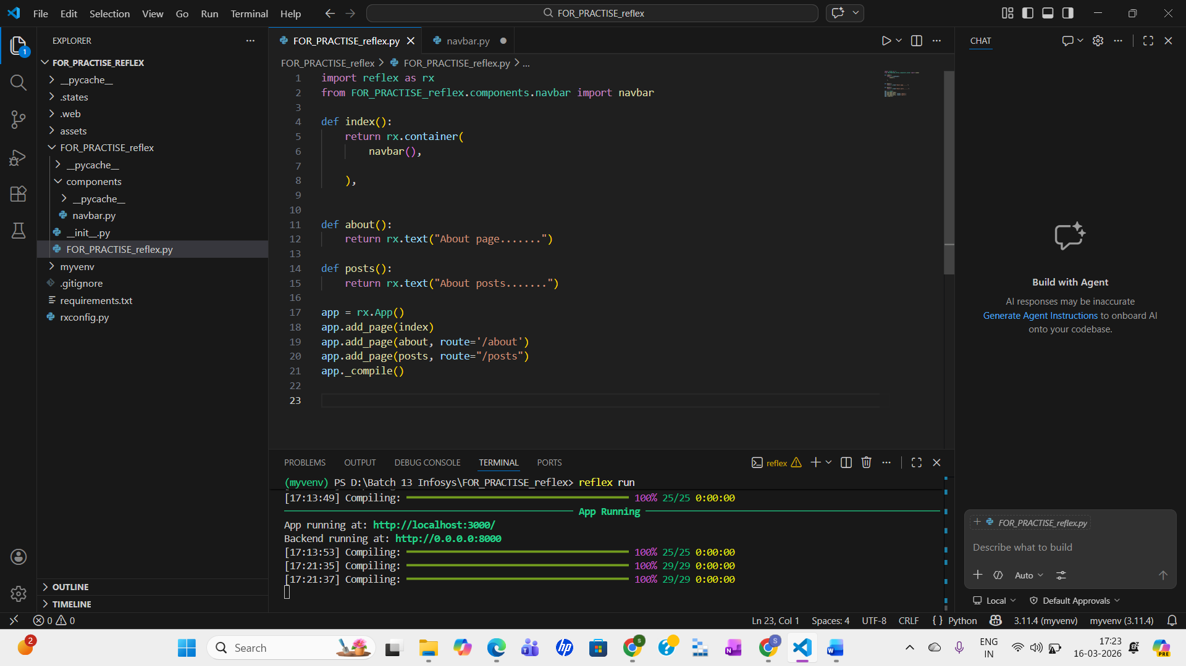

13. If I want to ensure that when someone clicks on the logo (for example, an added image), they are redirected to the home page, I will add an rx.link inside the navbar box. Within that link, I will place the rx.image and set the route to '/'.

def navbar():
return rx.flex(
rx.box(
rx.link(
rx.image(src='Chat bot-rafiki.png',
width='100px', align="left"), href='/')
),

Then, inside the About and Post pages, I will add the same content that the home page returns.
def about():
return rx.container(
navbar(),
rx.text('About app.....'))

def posts():
return rx.container(
navbar(),
rx.text('About posts....'))

14. The rx.container limits the content to a certain width and adds margins on the left and right. So, within a container, we can include elements like a navbar, text, buttons, and similar components.
15. To add a subtle line after the navbar, we can use rx.divider, as shown here:
- def index():
- return rx.container(
- navbar(),
- rx.divider(),
- rx.text('THis is a home page')
- )

- Now, let’s create a grid after the navbar so that we have two items. When the screen is medium-sized or larger, there will be two sections in one row, and when the screen is smaller, there will be only one column. To do this, I will create another component in the components folder named header.py.
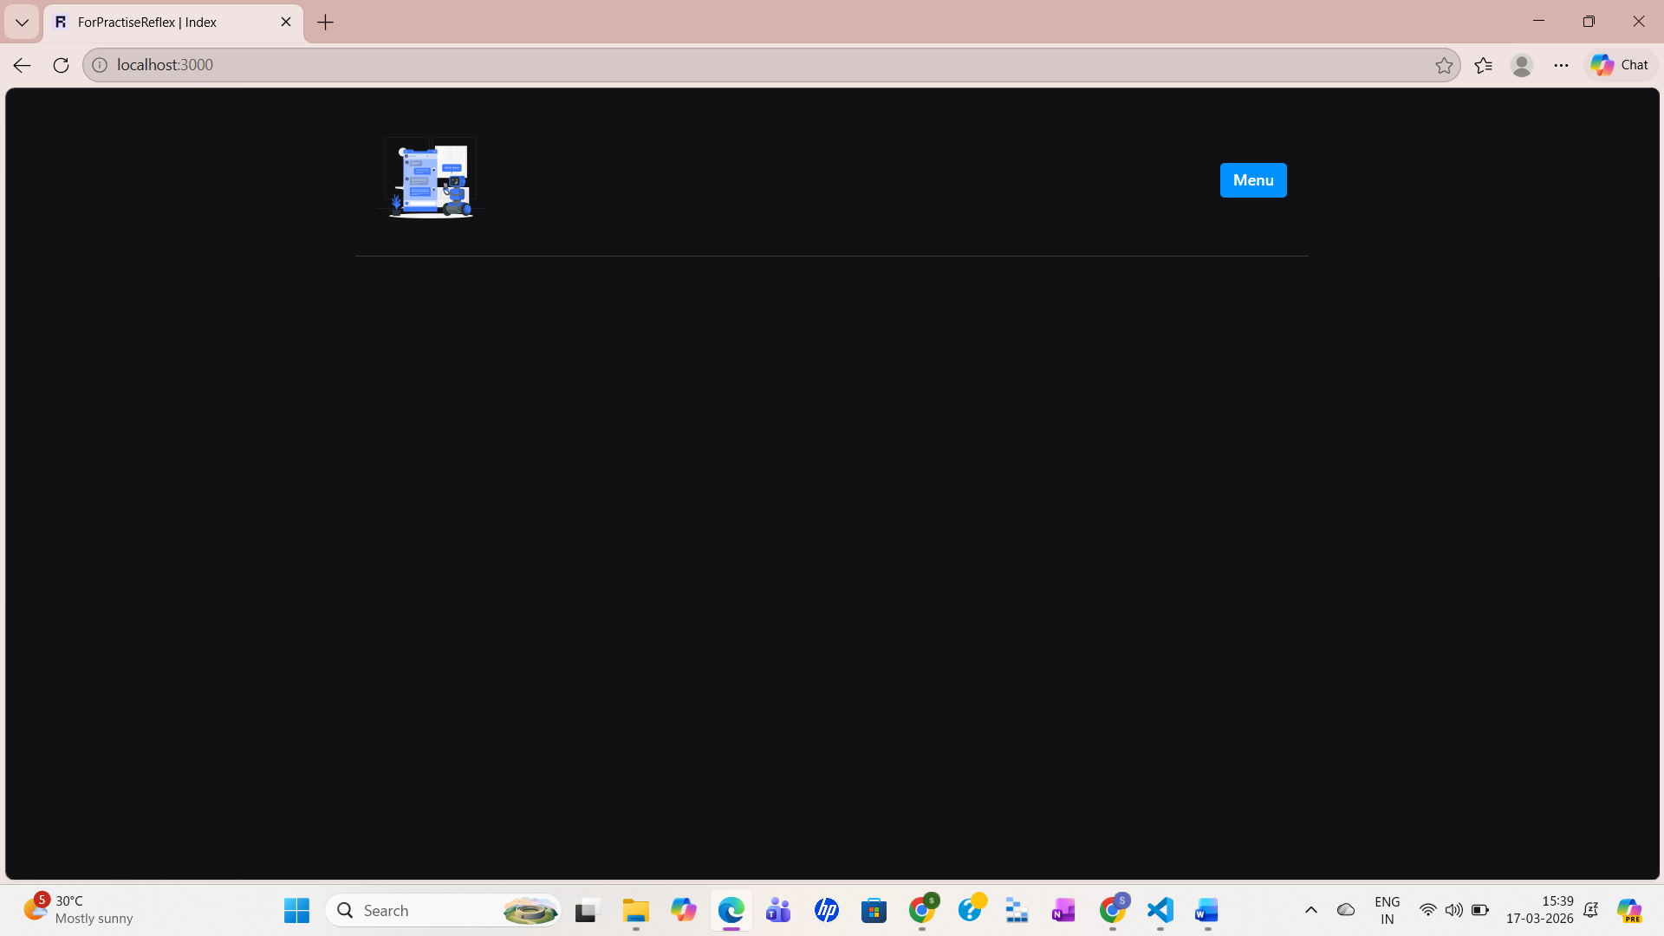
- In the header.py file, we have written this code, but it still does not have the feature to adjust the image layout based on the screen size.
- import reflex as rx

- def header():
- return rx.grid(
- rx.center(
- rx.box(
- rx.heading('I am Simran!'),
- rx.heading('This project is about.....,'),
- rx.button('Click here!')

- )
- ),
- rx.center(
- rx.image(src='Chat bot-rafiki.png')
- )
- )

18. So, to specify that we need two columns on medium and larger screens and one column on smaller screens, we will add a new prop columns={} directly inside rx.grid. This columns prop is a dictionary that defines the layout—for example, it sets one column for smaller screens.
def header():
return rx.grid(
rx.center(
rx.box(
rx.heading('I am Simran!'),
rx.heading('This project is about.....,'),
rx.button('Click here!')

)
),
rx.center(
rx.image(src='Chat bot-rafiki.png')
),
columns={
"base": "1",
"md": "2",
"lg": "3"
}
)

19. Now, let’s create a new function named quote, which we will add below the button on the home page. When a user clicks that button, a random quote will be generated and displayed in place of the author. First, add the code in the header.py file.
import reflex as rx

def header():
return rx.grid(
rx.center(
rx.box(
rx.heading("I am simran!"),
rx.heading("This project is about....."),
rx.button('Click here!'),
quote()
)
),
rx.center(
rx.image(src='Chat bot-rafiki.png')
),
columns= {
"base": "1",
"md": "2",
"lg": "3"

}
),

def quote():
return rx.box(
rx.text("........Quote"),
rx.text("author"))

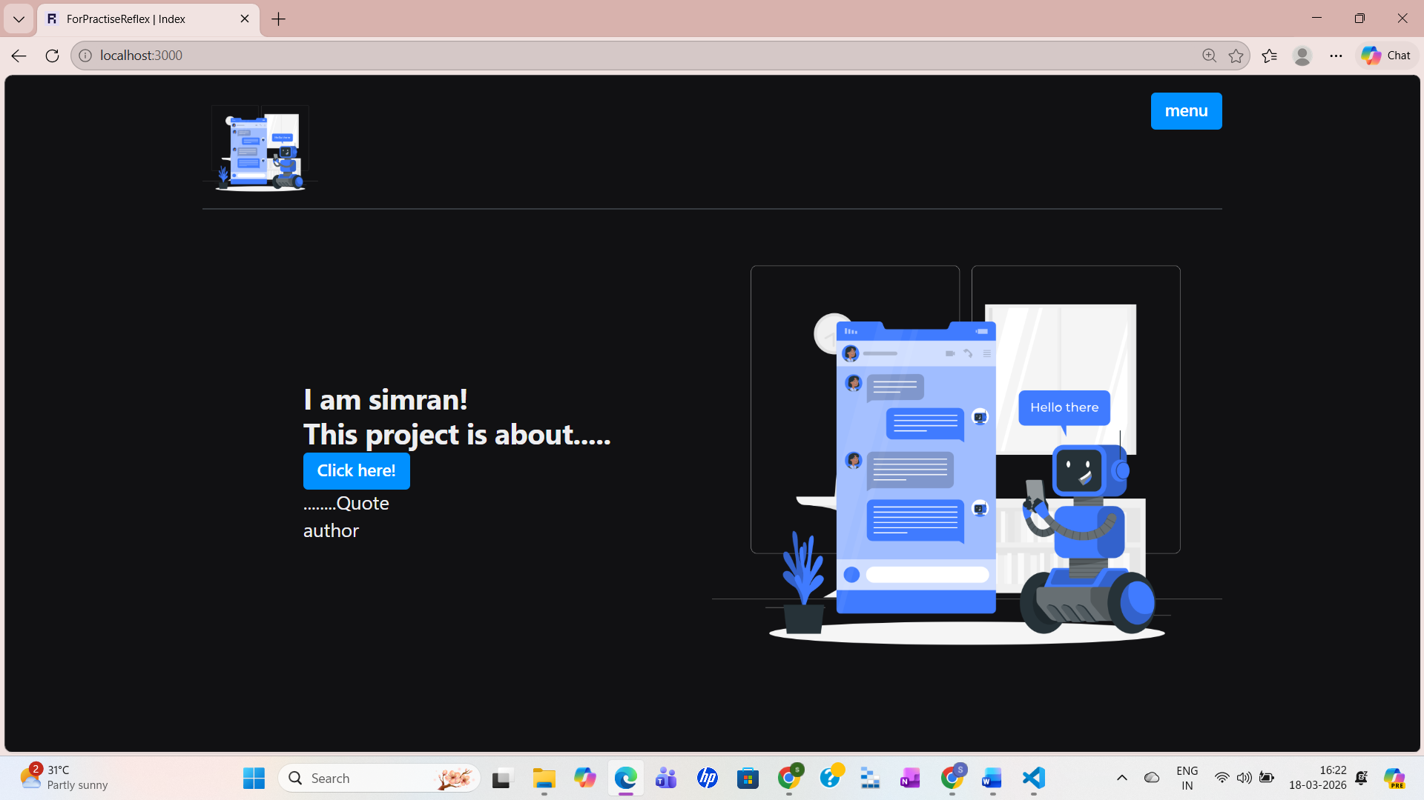
So, here we want that when we click on the “Click Here” button, we get a new quote along with its author every time. This brings us to the concept of state. State basically represents what you can currently see or do—it reflects the current status of your web page.
In this case, I want to change the state of the quote element—from the placeholder “Quote” text to an actual quote, and from the “Author” text to the corresponding author’s name. This involves controlling and managing the state of the application.
Now, let’s see how we can do that—how we can update the state of this quote to display a real quote.
This is a website where we can generate an API key for quotes.
https://forum.freecodecamp.org/t/free-api-inspirational-quotes-json-with-code-examples/311373
https://type.fit/api/quotes - This URL we will copy and add in our code.
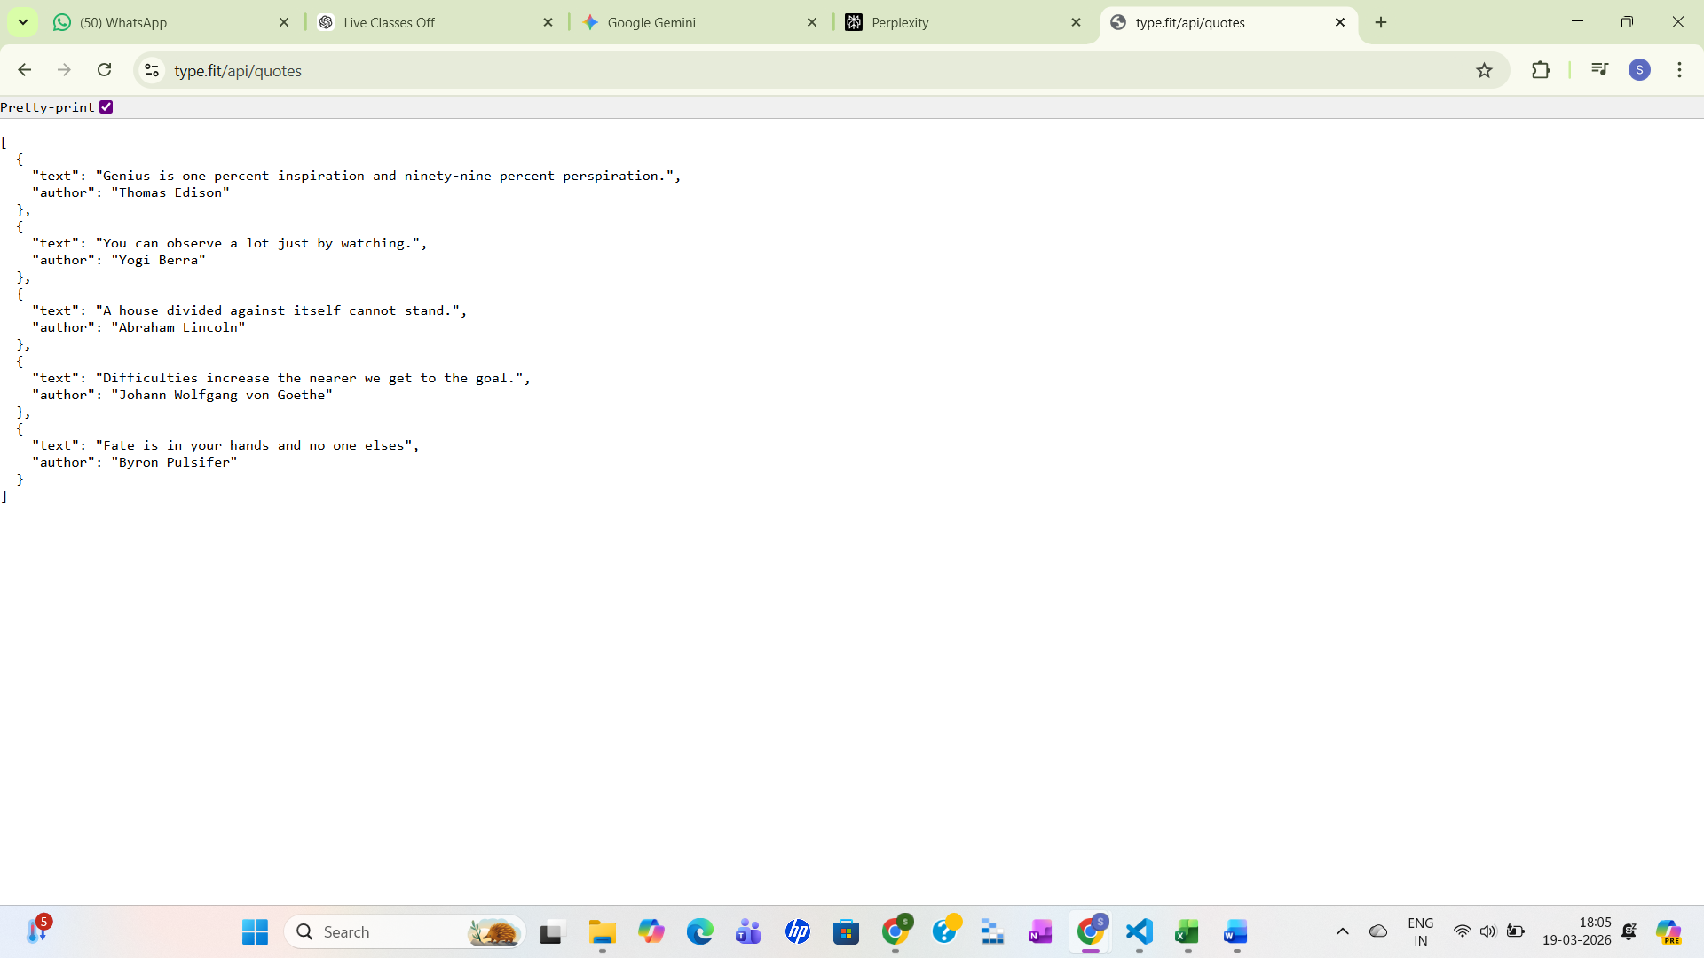

So, go to your header.py file and create a state. For that, we define a class—you can name it anything; I’ll call it MyState, and it will inherit from rx.State.
Inside this class, we create two instance variables:
quote = ''
author = ''
Then, we create a function that will fetch data from the API. This function will send a request to the URL, receive the response, extract the JSON data, and update the quote and author values accordingly.
Inside the function, first define the URL and send a request to that endpoint. The response will contain multiple details, such as the status code, but what we need is the JSON data. So, we convert the response into JSON using:
data = res.json()
Now, to update the state, we assign the first item from the JSON data:
self.quote = data[0]['text']
self.author = data[0]['author']
At this point, we have access to the first quote and its author.
Next, to display this in the UI, we connect the function to the button. In the “Click Here” button, we add an on_click event so that when the button is clicked, the get_quote function from MyState is triggered:
on_click = MyState.get_quote
Finally, in the UI where we display the quote and author, we replace the static text with state variables:
use MyState.quote instead of the placeholder quote text, and MyState.author instead of the placeholder author text.
Now, when you click the “Click Here” button, it will fetch and display the first quote from the API.

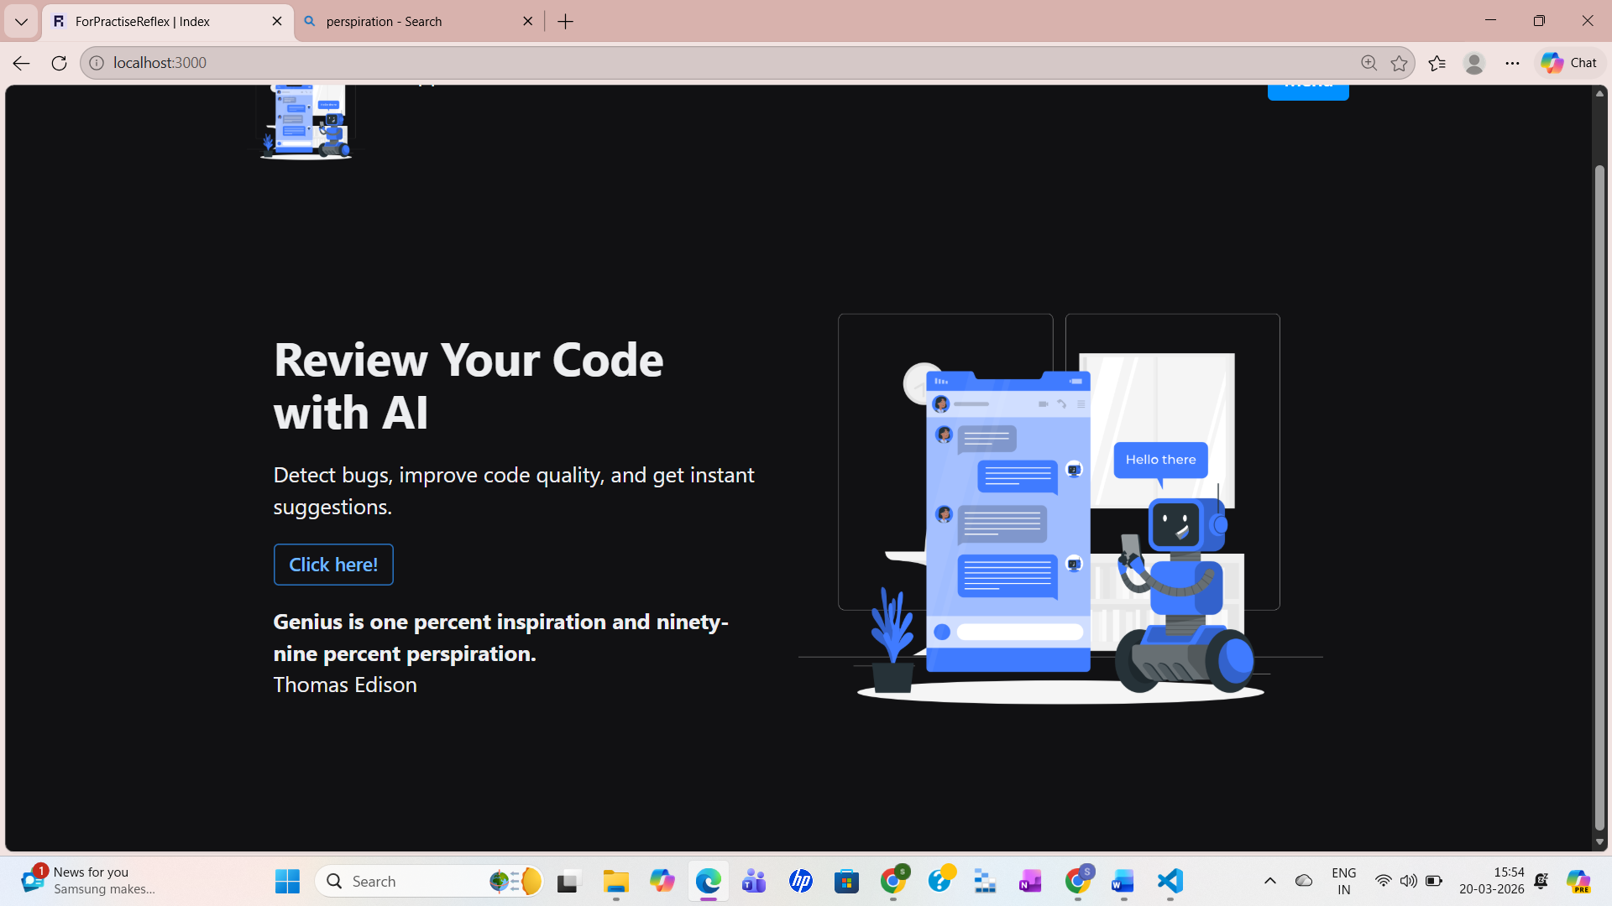

But, in this case, whenever I click the button, I always get the first quote and author based on the code above. However, what I want is to display a random quote each time the button is clicked.
To achieve this, I will use the random module in Python. First, I will import it:
import random
Then, inside the get_quote function, after retrieving the data, I will select a random index from the range of available quotes (from 0 to len(data)). I will use random.randrange() for this and store the result in a variable.
Finally, I will use that variable to assign values to self.quote and self.author, so that a random quote and its author are displayed each time the button is clicked.

import random

class Mystate(rx.State):
quote=""
author=""
def get_quote(self):
url = "https://type.fit/api/quotes"
res= requests.get(url)
data = res.json()
rand_num= random.randrange(0, len(data))
self.quote= data[rand_num]['text']
self.author= data[rand_num]['author']

